Meta Title:
Local SEO Services In Dubai | TAM
Meta Description:
Three Angle Marketing is the best SEO agency with a team of specialists in Google Maps and GMB optimization, Local Content Creation, and increased local traffic.

LOCAL SEO | Primary Keywords
 | local seo services Dubai
 | Local SEO agency Dubai
 | Local SEO expert
 | local business SEO services
 | local seo optimization services

Local SEO Agency In Dubai | Local Listings, Local Links, Local Leads
Are you facing issues related to lower visibility, poor growth, and inconsistency concerning NAP information? Our Dubai-based local SEO services can help you boost ranking and visibility by getting audience and search engine trust. As a leading local SEO agency in Dubai, we have professional expertise in GMB optimization, Google Maps SEO, and local SEO strategies to grow local audiences and deliver measurable ROI. You can rely on our expert solutions for local SEO solutions, local keyword research, local citation building, and local SEO services to build local trust and boost local visibility.

Call Us!

Fostering Your Local Profile by the Click of a Button!
Get Rank Higher On Google SERPS!
Getting found on top search results is not an easy task. Don’t worry our local business SEO services can help you achieve that in no time. You can expand your customer base easily not only locally but internationally by getting our services. Being a top-rated Local Search Engine Optimization agency, we will upgrade your local profile through our custom strategies crafted exclusively for your business needs. So, don’t stay behind and let your customers find your product and service online by getting in touch with us.
Click To Rank Higher!

TAM Local SEO Services In Dubai: Get Noticed Locally
Are you ready to take your business to the top of local searches? Our expert's proficiency in local SEO solutions has positioned TAM as a top-rated local Search Engine Optimization company. Moreover, our experts work very closely with our clients to make sure that custom strategies leave a positive impact on the product, services, business value, and ROI of our clients. Furthermore, our SEO strategist constantly analyzes and monitors current SEO strategies to find room for upgradation. Typically, our local SEO optimization services include of:

Local Market Analysis | Google Maps SEO | Google My Business SEO
With the use of content management systems, our Local SEO experts will analyze all opportunities in your local market business. After that, our experts will develop a CMS compatible with your business needs to make the content management process hassle-free. | Three Angle Marketing also offers Google Maps SEO in Dubai, UAE. To put our client's business online on Google Maps, our expert strategist will work on the local ranking of your products, and discoverability of products, and help you get more loyal customers. | Moreover, our SEO experts are also very proficient and specialized in the management or handling of Google My Business SEO. Our Custom GMB Optimization process surely can help to rank higher on local search engines through upgraded visibility.
Keyword Strategy | Local Link Building Strategy | SEO Auditing & Strategy
Our experts understand very well the importance of the keyword strategy. Because the right keyword with the right intent can help you achieve a higher ranking. That’s why our experts conduct thorough conduct on competitors and region-specific keywords to drive traffic. | The main purpose of our local link-building strategies is to increase the authority of your web page through relevant and high-quality links. That’s why our expert strategists craft high-researched local link-building custom strategies as per clients' needs. | There is no need to look further if you are searching for “Local SEO services near me” in Dubai. The qualified experts of TAM are fully equipped to conduct a thorough audit of your current SEO strategies and then make recommendations to solidify your local ranking.

Ready for Local SEO Take-off- Geo Target Your Success
If you are wondering why your business needs local Search Engine Optimization then let us clarify that it can help your small and medium-range business in numerous ways. The sales of your products and services will reach another level at the exact moment when your business profile reaches amongst top 5 search results. In this way, you can not only expand your business reach in your market but also improve your conversation rate. Moreover, here are some other benefits that you can grab by launching a successful local Search Engine Optimization campaign:

Grab More Audience Locally | Sell More Products Locally
We are not just ordinary SEO experts but a complete digital marketing agency that will look after every single need of brand awareness. From web development to keyword strategy and SEO optimization everything will be done in a specialized manner as per your business requirements. Moreover, we also specialized in the development of web layouts that fit perfectly to different screens. In this way, you can grab more audience locally by targeting them on different keywords, devices, and locations. | If you can successfully get the attention of more audience then increasing product sales will become a piece of cake for your business. It doesn’t matter which kind of business you are running, you won’t have to stress about your business profile, traffic, sales, or any other issue at all when you get local SEO for small business services of TAM. Our custom strategies will help your business get notified in your local market and help you connect with more potential customers than ever before.

FAQ’s

What is Local Search Engine Optimization?
Local Search Engine Optimization is somewhat similar to SEO with the same goals and objectives which is to improve website visibility on search engines in specific regions. Moreover, it is also referred to as “organic”, “Earned”, and “Natural” SEO.

What are the benefits of Local Search Engine Optimization?
There are many benefits that brands can get by implementing local Search Engine Optimization strategies such as higher traffic, more visibility, effective local campaigns, and domain authority. Moreover, there are other benefits too that attach to local Search Engine Optimization:
- Strong local community outreach
- More effective marketing campaigns
- Cheaper ads
- Appearance in Google's 3-pack
- Exposure to local listings

How much do TAM local Search Engine Optimization services cost?
As a leading local Search Engine Optimization agency, TAM pricing is not fixed; it depends on the nature of the job. You can get an idea about your project by consulting your project with our SEO specialist. Don’t worry our consultation process is free of cost. So, don’t waste time reaching us immediately.

Should I respond to negative reviews in Google My Business Listing?
Yes, of course, you should respond to all reviews of customers on your Google My Business listing irrespective of their nature whether they are positive or negative.

What are the different Factors that impact local search ranking?
Various factors leave a major impact on the local search ranking of businesses which include:
- Relevance of keywords
- Local SEO strategy
- Local Pages Authority
- Local Content Quality
- Local directory submissions
- Proximity of business
- Reputation in Market
- NAP consistency
- Content Depth
- Links Credibility
- Online reviews
Moreover, all these factors mostly determine how well your products and services can satisfy the needs of customers.

Is it possible to list my business in multiple local locations?
Yes, it is entirely possible to list your business in various local locations. What you need to do is just create GMB listings for your specific location after creating URLs for your designated multiple locations.

What is a local citation in marketing?
Location citation basically provides information about your business such as Email Address, Location Address, Social Media Handles, Online Directories, and Mobile Applications. The main purpose of location citations is to get verified by Google.

Is it possible to get instantly on a local search listing?
Yes, it is entirely possible. You can do that by investing your time, money, and energy in different factors such as local SEO marketing strategy, Local Schema Markup, GMB, Web Speed, Keyword Strategy, Build Local Trust and Research.

Which Tools TAM Used for Local Search Engine Optimization Purposes?
The following are the most prominent tools that local experts of Three Angle Marketing use:
- GMB Everywhere,
- Bright Local
- Localo
- Semrush
- Rank Tracking
- Seo Profiler

Do you also have expertise in e-commerce SEO Services?
TAM has comprehensive expertise in ecommerce SEO Services. Whether you want to build your online store from scratch or want to optimize your existing store, you can rely on our professional ecommerce SEO services.

Do you also offer Shopify SEO services?
If you are running a Shopify store and want to expand your business reach then you can rely on our expertise in Shopify SEO services which include:
- Keyword Research
- Site Speed Optimization
- Mobile-friendliness Improvements
- Content Marketing
- Mobile-friendliness Improvements

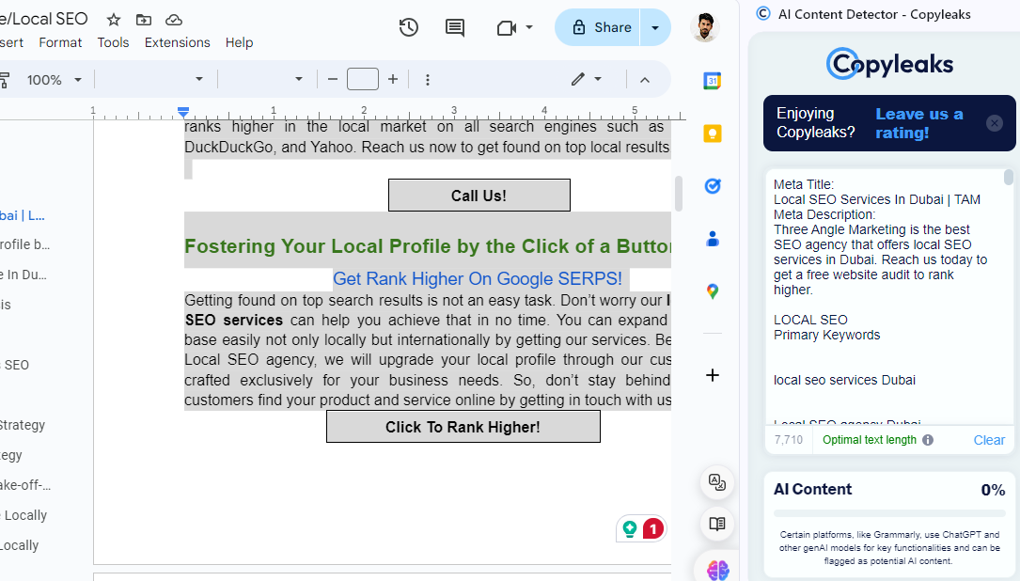

local SEO strategy

